1. Install Jupyter notebook and run the first program and share the screenshot of the output.

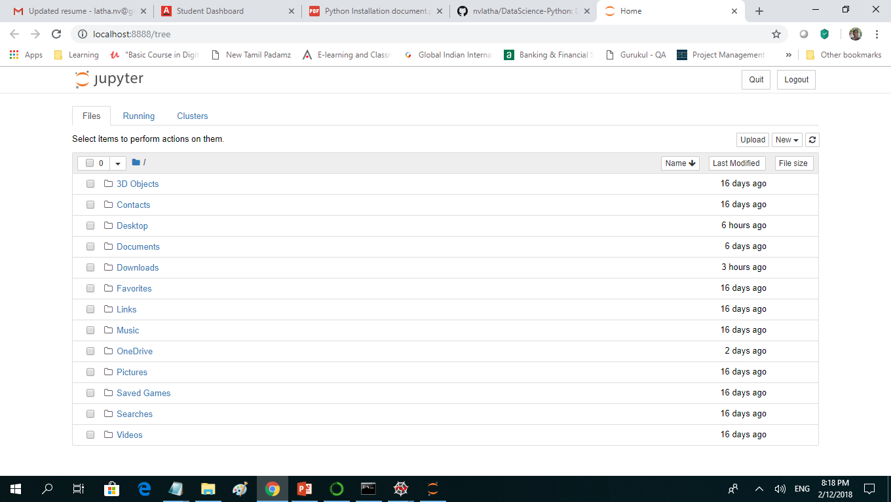

#Latha - First code - Assignment 1 - Problem 1

#1. Install Jupyter notebook and run the first program and share the screenshot of the output.

q=5

s="Latha"

t=2.0

A=type(q)

B= type(s)

C=type(t)

print(A)

print(B)

print(C)

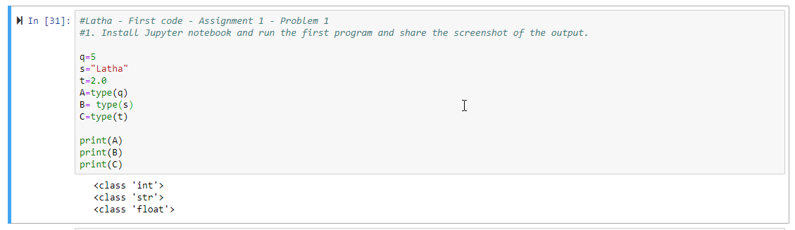

2. Write a program which will find all such numbers which are divisible by 7 but are not a

multiple of 5, between 2000 and 3200 (both included). The numbers obtained should be printed

in a comma-separated sequence on a single line.

Ans:

#Latha - First code - Assignment 1 - Problem 2

#2. Write a program which will find all such numbers which are divisible by 7 but are not a multiple of 5,

# between 2000 and 3200 (both included). The numbers obtained should be printed n a comma-separated sequence on a single line.

result=[]

for x in range(2000, 3200):

if (x%7==0) and (x%5!==0):

result.append(x)

print("Result = " + str(result))

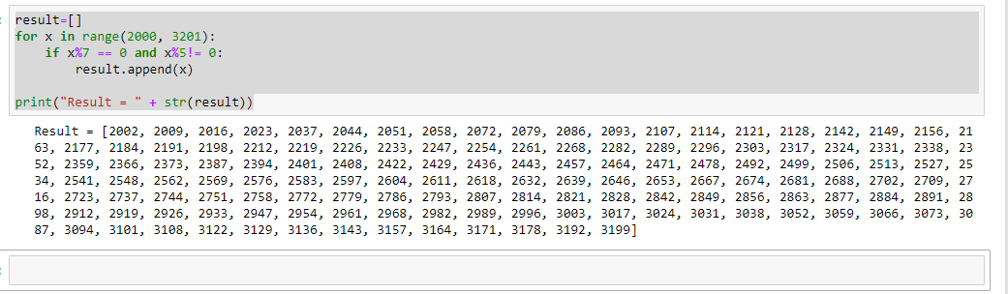

3. Write a Python program to accept the user's first and last name and then getting them printed

in the reverse order with a space between first name and last name.

#Latha - First code - Assignment 1 - Problem 3

#3. Write a Python program to accept the user's first and last name and then getting them printed

# in the reverse order with a space between first name and last name.

Fname= input("Enter the First Name :" )

Lname= input("Enter the Last Name :" )

Name = Fname+" " +Lname

print ("Reverse Order :" + Name[::-1])

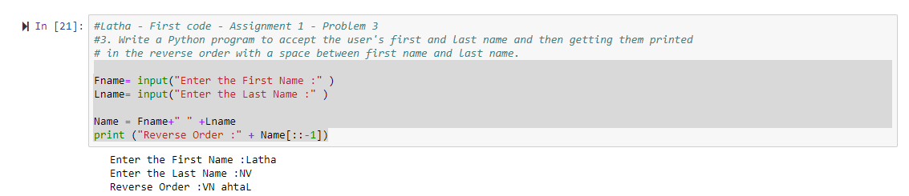

4. Write a Python program to find the volume of a sphere with diameter 12 cm.

Formula: V=4/3 * π * r

#Latha - First code - Assignment 1 - Problem 4

#4. Write a Python program to find the volume of a sphere with diameter 12 cm.

#Formula: V=4/3 * π * r

diameter=12

volume=(4/3)*(22/7)*(diameter/2)

volume = round(volume, 2)

print("Volume : " + str(volume))

